**P250/1**

**GEOGRAPHY**

**(PHYSICAL GEOGRAPHY)**

**PAPER 1**

**3 hours**

PAHISCO EXAMINATIONS BOARD

UGANDA ADVANCED CERTIFICATE OF EDUCATION

MOCK EXAMINATION 2022

GEOGRAPHY PAPER 1

3 HOURS

**INSTRUCTIONS TO CANDIDATES**

Answer four questions.

Section A is compulsory

At least one question should be answered from section B and one question from section C.

Credit will be given for use of relevant sketch maps, diagrams and specific examples studied in the field.

**SECTION A COMPLUSORY:**

1. Study the 1:50,000 east Africa (UGANDA) **KATUNGURU** map extract part of sheet 76/1, series Y732, Edition 4-USD and answer the questions that follow.
2. State the:
3. Man-made feature found at grid reference 801812 (01mk)
4. Bearing of the lake kyamwiga (grid reference 820800) from Hipo pools (grid reference 710890) (02mks)
5. Draw a cross section along Northing 76 from Easting 74 to Easting 82 and on it mark and name.
6. Any three land forms features
7. Any two drainage features
8. All weather roads (09mks)
9. Describe the:
10. Relief of the area shown on a map (06mks)
11. Relationship between relief and drainage. (04mks)
12. Explain the values of the craters to the national economy. (03mks)
13. Study the photograph provided below and answer the questions that follow.

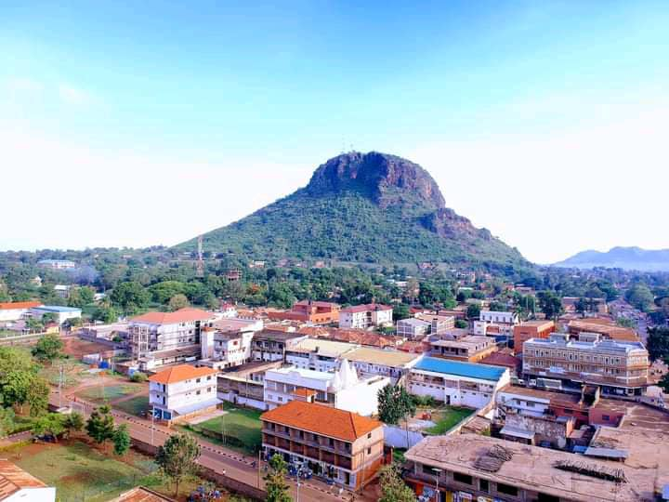

1. Draw a landscape sketch of the area shown in the photograph and on it mark and name:
2. Any two physiographic regions
3. Settlement
4. Vegetation (07mks)
5. Describe the formation of the landform in the back ground. (07 marks)
6. Explain the relationship between relief and land use as shown in the area above. (04mks)
7. Giving evidence from the photograph, explain the problems faced by the people living in the area. (05mks)
8. Giving reasons for your answer, suggest an area in Easy Africa where the photograph could have been taken. (02mks)

**SECTION B**

1. Account for the formation of the East African rift valley. (25mks)
2. Examine the influence of intrusive vulcanicity on the development of relief landforms in east Africa. (25mks)
3. Account for the dominance of physical weathering in the semi-arid areas of east Africa. (25mks)

**SECTION C**

**6.** (a) Describe how temperature is measured and recorded at a weather station. (10 marks)

(b)To what extent has the position of the overhead sun influenced temperature variations in East Africa***.*** (15 marks)

1. To what extent has the natural vegetation of east Africa been modified by human activities?

(25mks)

1. a). What is meant by the term “soil profile”? (10mks)

b). Explain the conditions which have influenced the soil profile development in the various parts of East Africa. (15mks)